X Lecture: Causative agent of zoonotic infections (genus Bruсella, Bacillus, Listeria, Yersinia, Francisella). Pathogenic members of Corynebacterium, Bordetella, Haemophilus, Gardnerella, Legionella genus.

The purpose of the lecture. Causative agents of zoonotic infections (brucellosis, black ulcer, listeriosis, plague and tularemia),morfo-biological properties , provide information on specific treatment and prevention principles. Morpho-biological properties of bacteria of the genus Corynebacterium, Bordetella, Haemophilus, Gardnerella, Legionella.
Lecture plan:
- Brussels sprouts. Classification, morpho-biological features. Bacteriological, serological, allergic examination methods. Specific treatment and prevention drugs.
- the causative agent of anthrax. Morpho-biological features, principles of microbiological diagnostics, specific treatment and prevention.
- causative agent of listeriosis, morpho-biological characteristics, microbiological diagnosis,specific prevention,treatment.
- yersinias. The perpetrator of the plague. Morpho-biological features, microbiological diagnostics, treatment and prevention .
- the causative agent of tularemia. Morpho-biological features,microbiology diagnosis. Specific prophylaxis and treatment drugs.
2.Bacteria of the genus Corynebacterium. Morpho-biological characteristics of diphtheria. Specific principles of prevention and treatment.
3.Bordetella, classification, morpho-biological characteristics, microbiological diagnosis, specific prevention and principles of treatment.
4. Hemophilic bacteria. H.influenzae, morpho-biological characteristics and microbiological diagnosis ,treatment and prevention.
- Legionella, their morpho-biological features, microbiological diagnosis of legionellosis,treatment and prevention.
- Gardnerella vaginalis, morpho-biological features, microbiological diagnosis,treatment and prevention.

Lecture equipment: Computer, projector, electronic slides
Literature: p. 1

BRUCELLA
Disease
Brucella species cause brucellosis (undulant fever).
Important Properties
Brucellae are small gram-negative rods without a capsule.The three major human pathogens and their animal reservoirs are Brucella melitensis (goats and sheep), Brucella abortus (cattle), and Brucella suis (pigs).
Pathogenesis & Epidemiology
The organisms enter the body either by ingestion of contaminated milk products or through the skin by direct contact in an occupational setting such as an abattoir. They localize in the reticuloendothelial system, namely, the lymph nodes, liver, spleen, and bone marrow. Many organisms are killed by macrophages, but some survive within these cells, where they are protected from antibody. The host response is granulomatous, with lymphocytes and epithelioid giant cells, which can progress to form focal abscesses. The mechanism of pathogenesis of these organisms is not well defined, except that endotoxin is involved. No exotoxins are produced.
Clinical Findings
After an incubation period of 1 to 3 weeks, nonspecific symptoms such as fever, chills, fatigue, malaise, anorexia, and weight loss occur. The onset can be acute or gradual. The undulating (rising-and-falling) fever pattern that gives the disease its name occurs in a minority of patients. Enlarged lymph nodes, liver, and spleen are frequently found. Pancytopenia occurs. Brucella melitensis infections tend to be more severe and prolonged, whereas those caused by B. abortus are more self-limited. Osteomyelitis is the most frequent complication. Secondary spread from person to person is rare.
Laboratory Diagnosis
Recovery of the organism requires the use of enriched culture media and incubation in 10% CO2. The organisms can be presumptively identified by using a slide agglutination test with Brucella antiserum, and the species can be identified by biochemical tests. If organisms are not isolated, analysis of a serum sample from the patient for a rise in antibody titer to Brucella can be used to make a diagnosis. In the absence of an acute-phase serum specimen, a titer of at least 1:160 in the convalescent-phase serum sample is diagnostic.
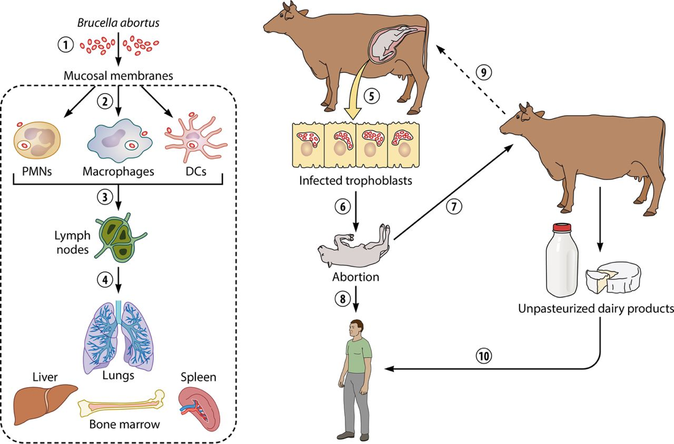

Treatment
The treatment of choice is tetracycline plus rifampin. There is no significant resistance to these drugs.
Prevention
Prevention of brucellosis involves pasteurization of milk, immunization of animals, and slaughtering of infected animals. There is no human vaccine.
BACILLUS
There are two medically important Bacillus species: Bacillus anthracis and Bacillus cereus.

1. Bacillus anthracis
Disease
Bacillus anthracis causes anthrax , which is common in animals but rare in humans. Human disease occurs in three main forms: cutaneous, pulmonary (inhalation), and gastrointestinal. In 2001, an outbreak of both inhalation and cutaneous anthrax occurred in the United States. The outbreak was caused by sending spores of the organism through the mail. There were 18 cases, causing 5 deaths in this outbreak.
Important Properties
Bacillus anthracis is a large gram-positive rod with square ends, frequently found in chains.Its antiphagocytic capsule is composed of D-glutamate. It is nonmotile, whereas other members of the genus are motile. Anthrax toxin is encoded on one plasmid, and the polyglutamate capsule is encoded on a different plasmid.
Transmission
Spores of the organism persist in soil for years. Humans are most often infected cutaneously at the time of trauma to the skin, which allows the spores on animal products, such as hides, bristles, and wool, to enter. Spores can also be inhaled into the respiratory tract. Pulmonary (inhalation) anthrax occurs when spores are inhaled into the lungs. Gastrointestinal anthrax occurs when contaminated meat is ingested. Inhalation anthrax is not communicable from person to person, despite the severity of the infection. After being inhaled into the lung, the organism moves rapidly to the mediastinal lymph nodes, where it causes hemorrhagic mediastinitis. Because it leaves the lung so rapidly, it is not transmitted by the respiratory route to others.
Pathogenesis
Pathogenesis is based primarily on the production of two exotoxins, collectively known as anthrax toxin. The two exotoxins, edema factor and lethal factor, each consist of two proteins in an A–B subunit configuration. The B, or binding, subunit in each of the two exotoxins is protective antigen. The A, or active, subunit has enzymatic activity. Edema factor, an exotoxin, is an adenylate cyclase that causes an increase in the intracellular concentration of cyclic adenosine monophosphate (AMP). This causes an outpouring of fluid from the cell into the extracellular space, which manifests as edema. (Note the similarity of action to that of cholera toxin.)
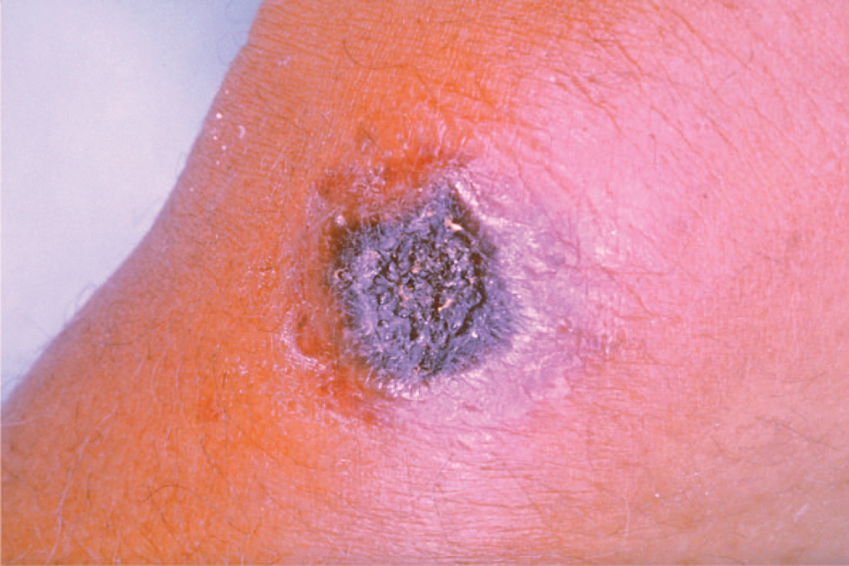
Skin lesion of anthrax. Note the black eschar, a necrotic lesion covered by a crust, caused by lethal factor, an exotoxin produced by Bacillus anthracis. Note the area of edema surrounding the eschar, which is caused by another exotoxin called edema factor.

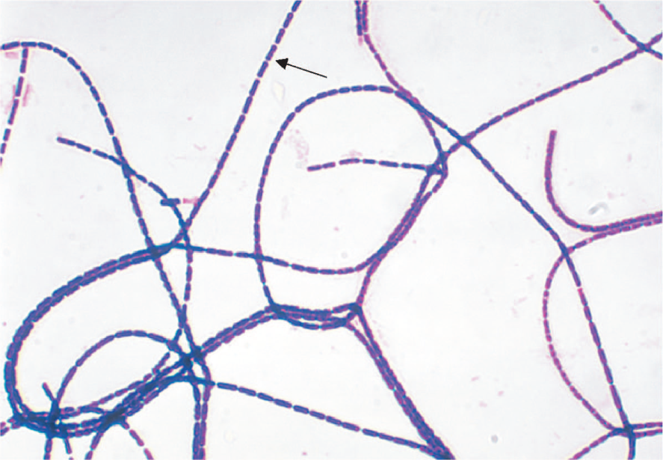
Bacillus anthracis—Gram stain. Arrow points to one large "box car–like" gram-positive rod within a long chain.
Lethal factor is a protease that cleaves the phosphokinase that activates the mitogen-activated protein kinase (MAPK) signal transduction pathway. This pathway controls the growth of human cells, and cleavage of the phosphokinase inhibits cell growth. Protective antigen forms pores in the human cell membrane that allows edema factor and lethal factor to enter the cell. The name protective antigen refers to the fact that antibody against this protein protects against disease.
Clinical Findings
The typical lesion of cutaneous anthrax is a painless ulcer with a black eschar (crust, scab) . Local edema is striking. The lesion is called a malignant pustule. Untreated cases progress to bacteremia and death. Pulmonary (inhalation) anthrax, also known as “wool-sorter’s disease,” begins with nonspecific respiratory tract symptoms resembling influenza, especially a dry cough and substernal pressure. This rapidly progresses to hemorrhagic mediastinitis, bloody pleural effusions, septic shock, and death. Although the lungs are infected, the classic features and X-ray picture of pneumonia are not present. Mediastinal widening seen on chest X-ray is an important diagnostic criterion. Hemorrhagic mediastinitis and hemorrhagic meningitis are severe life-threatening complications. The symptoms of gastrointestinal anthrax include vomiting, abdominal pain, and bloody diarrhea.
Laboratory Diagnosis
Smears show large, gram-positive rods in chains . Spores are usually not seen in smears of exudate because spores form when nutrients are insufficient, and nutrients are plentiful in infected tissue. Nonhemolytic colonies form on blood agar aerobically. In case of a bioterror attack, rapid diagnosis can be performed in special laboratories using polymerase chain reaction (PCR)– based assays. Another rapid diagnostic procedure is the direct fluorescent antibody test that detects antigens of the organism in the lesion. Serologic tests, such as an enzyme-linked immunosorbent assay (ELISA) test for antibodies, require acute and convalescent serum samples and can only be used to make a diagnosis retrospectively.
Treatment
Ciprofloxacin is the drug of choice. Doxycycline is an alternative drug. No resistant strains have been isolated clinically.
Prevention
Ciprofloxacin or doxycycline was used as prophylaxis in those exposed during the outbreak in the United States in 2001. People at high risk can be immunized with cellfree vaccine containing purified protective antigen as immunogen. The vaccine is weakly immunogenic, and six doses of vaccine over an 18-month period are given. Annual boosters are also given to maintain protection. Incinerating animals that die of anthrax, rather than burying them, will prevent the soil from becoming contaminated with spores.

2. Bacillus cereus
Disease
Bacillus cereus causes food poisoning.
Transmission
Spores on grains such as rice survive steaming and rapid frying. The spores germinate when rice is kept warm for many hours (e.g., reheated fried rice). The portal of entry is the gastrointestinal tract.
Pathogenesis
Bacillus cereus produces two enterotoxins. The mode of action of one of the enterotoxins is the same as that of cholera toxin (i.e., it adds adenosine diphosphate ribose, a process called ADP-ribosylation, to a G protein, which stimulates adenylate cyclase and leads to an increased concentration of cyclic AMP within the enterocyte). The mode of action of the other enterotoxin resembles that of staphylococcal enterotoxin (i.e., it is a superantigen).
Clinical Findings
There are two syndromes. (1) One syndrome has a short incubation period (4 hours) and consists primarily of nausea and vomiting, similar to staphylococcal food poisoning. (2) The other has a long incubation period (18 hours) and features watery, nonbloody diarrhea, resembling clostridial gastroenteritis.
Laboratory Diagnosis
This is not usually done.
Treatment
Only symptomatic treatment is given.
Prevention
There is no specific means of prevention. Rice should not be kept warm for long periods.

LISTERIA
Diseases
Listeria monocytogenes causes meningitis and sepsis in newborns, pregnant women, and immunosuppressed adults. It also causes outbreaks of febrile gastroenteritis. It is a major cause of concern for the food industry.
Important Properties
Listeria monocytogenes is a small gram-positive rod arranged in V- or L-shaped formations similar to corynebacteria. The organism exhibits an unusual tumbling movement that distinguishes it from the corynebacteria, which are nonmotile. Colonies on a blood agar plate produce a narrow zone of β-hemolysis that resembles the hemolysis of some streptococci. Listeria grows well at cold temperatures, so storage of contaminated food in the refrigerator can increase the risk of gastroenteritis. This paradoxical growth in the cold is called “cold enhancement.”
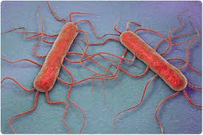
Pathogenesis
Listeria infections occur primarily in two clinical settings: (1) in the fetus or in a newborn as a result of transmission across the placenta or during delivery; and (2) in pregnant women and immunosuppressed adults, especially renal transplant patients. (Note that pregnant women have reduced cellmediated immunity during the third trimester.)The organism is distributed worldwide in animals, plants, and soil. From these reservoirs, it is transmitted to humans primarily by ingestion of unpasteurized milk products, undercooked meat, and raw vegetables. Contact with domestic farm animals and their feces is also an important source. In the United States, listeriosis is primarily a foodborne disease associated with eating unpasteurized cheese and delicatessen meats. Following ingestion, the bacteria appear in the colon and then can colonize the female genital tract. From this location, they can infect the fetus if membranes rupture or infect the neonate during passage through the birth canal. The pathogenesis of Listeria depends on the organism’s ability to invade and survive within cells. Invasion of cells is mediated by internalin made by Listeria and E-cadherin on the surface of human cells. The ability of Listeria to pass the placenta, enter the meninges, and invade the gastrointestinal tract depends on the interaction of internalin and E-cadherin on those tissues. Upon entering the cell, the organism produces listeriolysin, which allows it to escape from the phagosome into the cytoplasm, thereby escaping destruction in the phagosome. Because Listeria preferentially grows intracellularly, cell-mediated immunity is a more important host defense than humoral immunity. Suppression of cell-mediated immunity predisposes to Listeria infections. Listeria monocytogenes can move from cell to cell by means of actin rockets—filaments of actin polymerize and propel the bacteria through the membrane of one human cell and into another.
Clinical Findings
Infection during pregnancy can cause abortion, premature delivery, or sepsis during the peripartum period. Newborns infected at the time of delivery can have acute meningitis 1 to 4 weeks later. The bacteria reach the meninges via the bloodstream (bacteremia). The infected mother either is asymptomatic or has an influenzalike illness. Listeria monocytogenes infections in immunocompromised adults can be either sepsis or meningitis. Gastroenteritis caused by L. monocytogenes is characterized by watery diarrhea, fever, headache, myalgias, and abdominal cramps but little vomiting. Outbreaks are usually caused by contaminated dairy products, but undercooked meats such as chicken and hot dogs and ready-to-eat foods such as coleslaw have also been involved.
Laboratory Diagnosis
Laboratory diagnosis is made primarily by Gram stain and culture. The appearance of gram-positive rods resembling diphtheroids and the formation of small, gray colonies with a narrow zone of β-hemolysis on a blood agar plate suggest the presence of Listeria. The isolation of Listeria is confirmed by the presence of motile organisms, which differentiate them from the nonmotile corynebacteria. Identification of the organism as L. monocytogenes is made by sugar fermentation tests.
Treatment
Treatment of invasive disease, such as meningitis and sepsis, consists of trimethoprim-sulfamethoxazole. Combinations, such as ampicillin and gentamicin or ampicillin and trimethoprim-sulfamethoxazole, can also be used. Resistant strains are rare. Listeria gastroenteritis typically does not require treatment.
Prevention
Prevention is difficult because there is no immunization. Limiting the exposure of pregnant women and immunosuppressed patients to potential sources such as farm animals, unpasteurized milk products, and raw vegetables is recommended. Trimethoprim-sulfamethoxazole given to immunocompromised patients to prevent Pneumocystis pneumonia can also prevent listeriosis.

YERSINIA
Disease
Yersinia pestis is the cause of plague, also known as the black death, the scourge of the Middle Ages. It is also a contemporary disease, occurring in the western United States and in many other countries around the world.
Important Properties
Yersinia pestis is a small gram-negative rod that exhibits bipolar staining (i.e., it resembles a safety pin, with a central clear area). Freshly isolated organisms possess a capsule composed of a polysaccharide–protein complex. The capsule can be lost with passage in the laboratory; loss of the capsule is accompanied by a loss of virulence. It is one of the most virulent bacteria known and has a strikingly low ID50 (i.e., 1–10 organisms are capable of causing disease).
Pathogenesis & Epidemiology
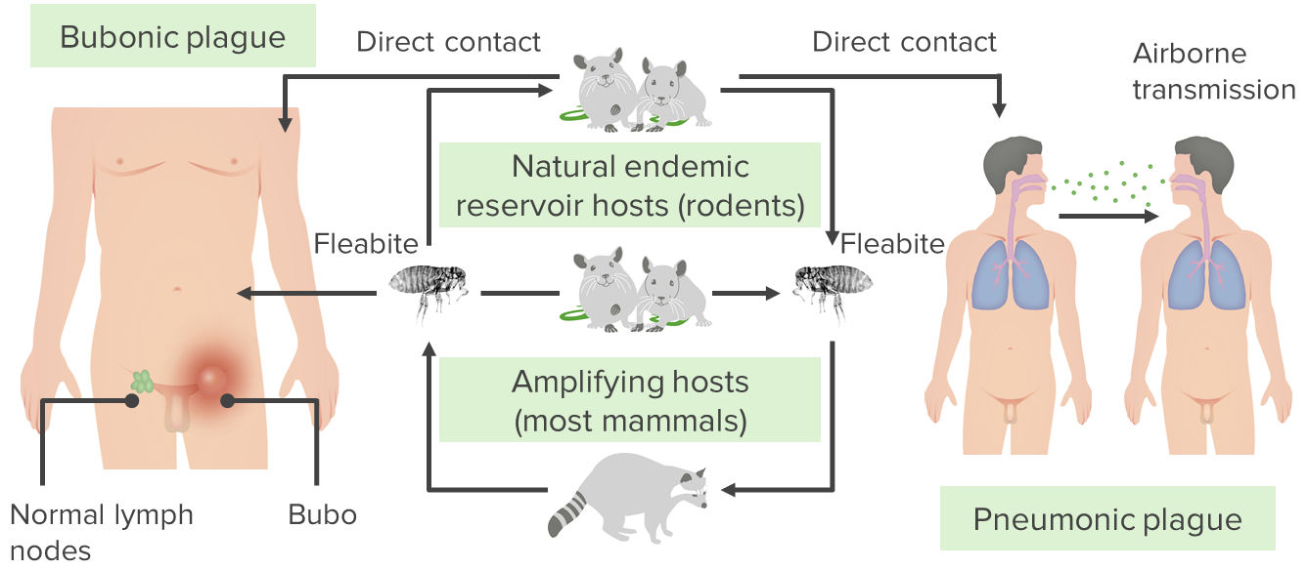
The organisms inoculated at the time of the bite spread to the regional lymph nodes, which become swollen and tender. These swollen lymph nodes are the buboes that have led to the name bubonic plague. The organisms can reach high concentrations in the blood (bacteremia) and disseminate to form abscesses in many organs. The endotoxin-related symptoms, including disseminated intravascular coagulation and cutaneous hemorrhages, probably were the genesis of the term black death. In addition to the sylvatic and urban cycles of transmission, respiratory droplet transmission of the organism from patients with pneumonic plague can occur. The organism has several factors that contribute to its virulence: (1) the envelope capsular antigen, called F-1, which protects against phagocytosis; (2) endotoxin; (3) an exotoxin; and (4) two proteins known as V antigen and W antigen. The V and W antigens allow the organism to survive and grow intracellularly, but their mode of action is unknown. The action of the exotoxin is unknown. Other factors that contribute to the extraordinary pathogenicity of Y. pestis are a group of virulence factors collectively called Yops (Yersinia outer proteins). These are injected into the human cell via type III secretion systems and inhibit phagocytosis and cytokine production by macrophages and neutrophils. For example, one of the Yops proteins (YopJ) is a protease that cleaves two signal transduction pathway proteins required for the induction of tumor necrosis factor synthesis. This inhibits the activation of our host defenses and contributes to the ability of the organism to replicate rapidly within the infected individual.
Clinical Findings
Bubonic plague, which is the most frequent form, begins with pain and swelling of the lymph nodes draining the site of the flea bite and systemic symptoms such as high fever, myalgias, and prostration. The affected nodes enlarge and become exquisitely tender. These buboes are an early characteristic finding. Septic shock and pneumonia are the main life-threatening subsequent events. Pneumonic plague can arise either from inhalation of an aerosol or from septic emboli that reach the lungs. Untreated bubonic plague is fatal in approximately half of the cases, and untreated pneumonic plague is invariably fatal.
Laboratory Diagnosis
Smear and culture of blood or pus from the bubo is the best diagnostic procedure. Great care must be taken by the physician during aspiration of the pus and by laboratory workers doing the culture not to create an aerosol that might transmit the infection. Giemsa or Wayson stain reveals the typical safety-pin appearance of the organism better than does Gram stain. Fluorescent-antibody staining can be used to identify the organism in tissues. A rise in antibody titer to the envelope antigen can be useful retrospectively.
Treatment
The treatment of choice is a combination of streptomycin and a tetracycline such as doxycycline, although streptomycin alone can be used. Levofloxacin can also be used. There is no significant antibiotic resistance. In view of the rapid progression of the disease, treatment should not wait for the results of the bacteriologic culture. Incision and drainage of the buboes are not usually necessary.
Prevention
Prevention of plague involves controlling the spread of rats in urban areas, preventing rats from entering the country by ship or airplane, and avoiding both flea bites and contact with dead wild rodents. A patient with plague must be placed in strict isolation (quarantine) for 72 hours after antibiotic therapy is started. Only close contacts need to receive prophylactic tetracycline, but all contacts should be observed for fever. Reporting a case of plague to the public health authorities is mandatory. A vaccine consisting of formalin-killed organisms provides partial protection against bubonic but not pneumonic Plague.
FRANCISELLA
Disease
Francisella tularensis causes tularemia.
Important Properties
Francisella tularensis is a small, pleomorphic gram-negative rod. It has a single serologic type. There are two biotypes, A and B, which are distinguished primarily on their virulence and epidemiology. Type A is more virulent and found primarily in the United States, whereas type B is less virulent and found primarily in Europe.
Pathogenesis & Epidemiology
Francisella tularensis is remarkable in the wide variety of animals that it infects and in the breadth of its distribution in the United States. It is enzootic (endemic in animals) in every state, but most human cases occur in the rural areas of Arkansas and Missouri. It has been isolated from more than 100 different species of wild animals, the most important of which are rabbits, deer, and a variety of rodents. The bacteria are transmitted among these animals by vectors such as ticks, mites, and lice, especially the Dermacentor ticks that feed on the blood of wild rabbits. The tick maintains the chain of transmission by passing the bacteria to its offspring by the transovarian route. In this process, the bacteria are passed through ovum, larva, and nymph stages to adult ticks capable of transmitting the infection. Humans are accidental “dead-end” hosts who acquire the infection most often by being bitten by the vector or by having skin contact with the animal during removal of the hide. Rarely, the organism is ingested in infected meat, causing gastrointestinal tularemia, or is inhaled, causing pneumonia. There is no person-to-person spread. The organism enters through the skin, forming an ulcer at the site in most cases. It then localizes to the cells of the reticuloendothelial system, and granulomas are formed. Caseation necrosis and abscesses can also occur. Symptoms are caused primarily by endotoxin. No exotoxins have been identified.
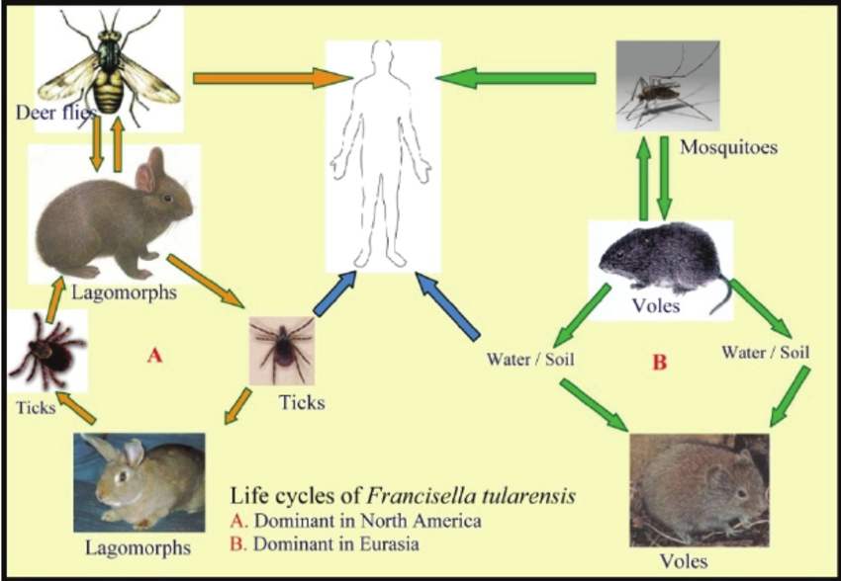
Clinical Findings
Presentation can vary from sudden onset of an influenzalike syndrome to prolonged onset of a low-grade fever and adenopathy. Approximately 75% of cases are the “ulceroglandular” type, in which the site of entry ulcerates and the regional lymph nodes are swollen and painful. Other, less frequent forms of tularemia include glandular, oculoglandular, typhoidal, gastrointestinal, and pulmonary. Disease usually confers lifelong immunity.
Laboratory Diagnosis
Attempts to culture the organism in the laboratory are rarely undertaken, because there is a high risk to laboratory workers of infection by inhalation, and the special cysteinecontaining medium required for growth is not usually available. The most frequently used diagnostic method is the agglutination test with acute- and convalescent-phase serum samples. Fluorescent-antibody staining of infected tissue can be used if available.
Treatment
Streptomycin is the drug of choice. There is no significant antibiotic resistance.
Prevention
Prevention involves avoiding both being bitten by ticks and handling wild animals. There is a live, attenuated bacterial vaccine that is given only to persons, such as fur trappers, whose occupation brings them into close contact with wild Animals.

CORYNEBACTERİUM
Important Properties
Corynebacteria are gram-positive rods that appear clubshaped (wider at one end) and are arranged in palisades or in V- or L-shaped formations . The rods have a beaded appearance. The beads consist of granules of highly polymerized polyphosphate—a storage mechanism for high-energy phosphate bonds. The granules stain metachromatically (i.e., a dye that stains the rest of the cell blue will stain the granules red).
Transmission
Humans are the only natural host of C. diphtheriae. Both toxigenic and nontoxigenic organisms reside in the upper respiratory tract and are transmitted by airborne droplets. The organism can also infect the skin at the site of a preexisting skin lesion. This occurs primarily in the tropics but can occur worldwide in indigent persons with poor skin hygiene.
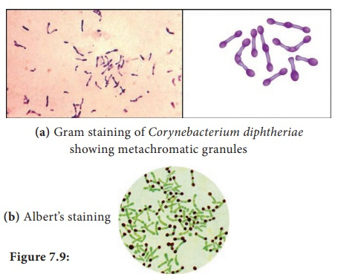
Pathogenesis
Although exotoxin production is essential for pathogenesis,invasiveness is also necessary because the organism must first establish and maintain itself in the throat. Diphtheria toxin inhibits protein synthesis by ADP-ribosylation of elongation factor-2 (EF-2). The toxin affects all eukaryotic cells regardless of tissue type but has no effect on the analogous factor in prokaryotic cells. The toxin is a single polypeptide with two functional domains. The binding (B) domain mediates binding of the toxin to glycoprotein receptors on the cell membrane. The active (A) domain possesses enzymatic activity that cleaves nicotinamide from nicotinamide adenine dinucleotide (NAD) and transfers the remaining ADP-ribose to EF-2, thereby inactivating it.The DNA that codes for diphtheria toxin is part of the DNA of a temperate bacteriophage called beta phage. During the lysogenic phase of viral growth, the DNA of this virus integrates into the bacterial chromosome and the toxin is synthesized. Corynebacterium diphtheriae cells that are not lysogenized by this phage do not produce exotoxin and are nonpathogenic. The host response to C. diphtheriae consists of the following: (1) A local inflammation in the throat, with a fibrinous exudate that forms the tough, adherent, gray pseudomembrane characteristic of the disease. (2) Antibody that can neutralize exotoxin activity by blocking the interaction of the binding domain with the receptors, thereby preventing entry into the cell. The immune status of a person can be assessed by Schick’s test. The test is performed by intradermal injection of 0.1 mL of purified standardized toxin. If the patient has no antitoxin, the toxin will cause inflammation at the site 4 to 7 days later. If no inflammation occurs, antitoxin is present and the patient is immune. The test is rarely performed in the United States except under special epidemiologic circumstances.
Clinical Findings
Although diphtheria is rare in the United States, physicians should be aware of its most prominent sign, the thick, gray,adherent pseudomembrane over the tonsils and throat. The other aspects are nonspecific: fever, sore throat, and cervical adenopathy. There are three prominent complications: (1) Extension of the membrane into the larynx and trachea, causing airway obstruction. (2) Myocarditis accompanied by arrhythmias and circulatory Collapse. (3) Nerve weakness or paralysis, especially of the cranial nerves. Paralysis of the muscles of the soft palate and pharynx can lead to regurgitation of fluids through the nose. Peripheral neuritis affecting the muscles of the extremities also occurs. Cutaneous diphtheria causes ulcerating skin lesions covered by a gray membrane. These lesions are often indolent and often do not invade surrounding tissue. Systemic symptoms rarely occur. In the United States, cutaneous diphtheria occurs primarily in the indigent.
Laboratory Diagnosis
Laboratory diagnosis involves both isolating the organism and demonstrating toxin production. It should be emphasized that the decision to treat with antitoxin is a clinical one and cannot wait for the laboratory results. A throat swab should be cultured on Loeffler’s medium, a tellurite plate, and a blood agar plate. The tellurite plate contains a tellurium salt that is reduced to elemental tellurium within the organism. The typical gray-black color of tellurium in the colony is a telltale diagnostic criterion. If C. diphtheriae is recovered from the cultures, either animal inoculation or an antibody-based gel diffusion precipitin test is performed to document toxin production. A PCR assay for the presence of the toxin gene in the organism isolated from the patient can also be used. Smears of the throat swab should be stained with both Gram stain and methylene blue. Although the diagnosis of diphtheria cannot be made by examination of the smear, the finding of many tapered, pleomorphic gram-positive rods can be suggestive. The methylene blue stain is excellent for revealing the typical metachromatic granules.

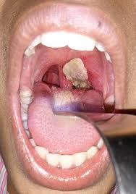
Treatment
The treatment of choice is antitoxin, which should be given immediately on the basis of clinical impression because there is a delay in laboratory diagnostic procedures. The toxin binds rapidly and irreversibly to cells and, once bound, cannot be neutralized by antitoxin. The function of antitoxin is therefore to neutralize unbound toxin in the blood. Because the antiserum is made in horses, the patient must be tested for hypersensitivity, and medications for the treatment of anaphylaxis must be available. Serum sickness may occur after administration of antiserum made in horses. Treatment with penicillin G or erythromycin is also recommended, but neither is a substitute for antitoxin. Antibiotics inhibit growth of the organism, reduce toxin production, and decrease the incidence of chronic carriers. Prevention Diphtheria is very rare in the United States because children are immunized with diphtheria toxoid (usually given as a combination of diphtheria toxoid, tetanus toxoid, and acellular pertussis vaccine, often abbreviated as DTaP). Diphtheria toxoid is prepared by treating the exotoxin with formaldehyde. This treatment inactivates the toxic effect but leaves the antigenicity intact. Immunization consists of three doses given at 2, 4, and 6 months of age, with boosters at 1 and 6 years of age. Because immunity wanes, a booster every 10 years is recommended. Immunization does not prevent nasopharyngeal carriage of the organism.

BORDETELLA
Disease
Bordetella pertussis causes whooping cough (pertussis).
Important Properties
Bordetella pertussis is a small, coccobacillary, encapsulated gram-negative rod.
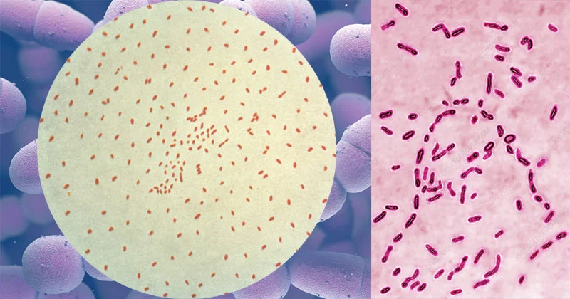
Pathogenesis & Epidemiology
Bordetella pertussis, a pathogen only for humans, is transmitted by airborne droplets produced during the severe coughing episodes. The organisms attach to the ciliated epithelium of the upper respiratory tract but do not invade the underlying tissue. Decreased cilia activity and subsequent death of the ciliated epithelial cells are important aspects of pathogenesis. Pertussis is a highly contagious disease that occurs primarily in infants and young children and has a worldwide distribution. The number of cases has declined in the United States because use of the vaccine is widespread. However, outbreaks of pertussis during the years 2005, 2010, and 2012 has led to concern about waning immunity to the vaccine and to the recommendation that an additional booster immunization be given (see “Prevention”). Several factors play a role in the pathogenesis: (1) Attachment of the organism to the cilia of the epithelial cells is mediated by a protein on the pili called filamentous hemagglutinin. Antibody against the filamentous hemagglutinin inhibits attachment and protects against disease. (2) Pertussis toxin stimulates adenylate cyclase by catalyzing the addition of adenosine diphosphate ribose—a process called ADP-ribosylation—to the inhibitory subunit of the G protein complex (Gi protein). This results in prolonged stimulation of adenylate cyclase and a consequent rise in cyclic adenosine monophosphate (AMP) and in cyclic AMP–dependent protein kinase activity. This results in edema of the respiratory mucosa that contributes to the severe cough of pertussis. The toxin also has a domain that mediates its binding to receptors on the surface of respiratory tract epithelial cells. It is an A-B subunit toxin. Pertussis toxin also causes a striking lymphocytosis in the blood of patients with pertussis. The toxin inhibits signal transduction by chemokine receptors, resulting in a failure of lymphocytes to enter lymphoid tissue such as the spleen and lymph nodes. Because the lymphocytes do not enter lymphoid tissue, there is an increase in their number in the blood. The inhibition of signal transduction by chemokine receptors is also caused by ADP-ribosylation of the Gi Protein. (3) The organisms also synthesize and export adenylate cyclase. This enzyme, when taken up by phagocytic cells (e.g., neutrophils), can inhibit their bactericidal activity. Bacterial mutants that lack cyclase activity are avirulent. (4) Tracheal cytotoxin is a fragment of the bacterial peptidoglycan that damages ciliated cells of the respiratory tract. Tracheal cytotoxin appears to act in concert with endotoxin to induce nitric oxide, which kills the ciliated epithelial cells.
Clinical Findings
Whooping cough is an acute tracheobronchitis that begins with mild upper respiratory tract symptoms followed by a severe paroxysmal cough, which lasts from 1 to 4 weeks. The paroxysmal pattern is characterized by a series of hacking coughs, accompanied by production of copious amounts of mucus, that end with an inspiratory “whoop” as air rushes past the narrowed glottis. Despite the severity of the symptoms, the organism is restricted to the respiratory tract and blood cultures are negative. A pronounced leukocytosis with up to 70% lymphocytes is seen. Although central nervous system anoxia and exhaustion can occur as a result of the severe coughing, death is due mainly to pneumonia. The classic picture of whooping cough described above occurs primarily in young children. In adults, B. pertussis infection often manifests as a paroxysmal cough of varying severity lasting weeks. The characteristic whoop is often absent, leading to difficulty in recognizing the cough as caused by this organism. In the correct clinical setting, adults with a cough lasting several weeks (often called the 100-day cough) should be evaluated for infection with B. pertussis.
Laboratory Diagnosis
The organism can be isolated from nasopharyngeal swabs taken during the paroxysmal stage. Bordet-Gengou1 medium used for this purpose contains a high percentage of blood (20%–30%) to inactivate inhibitors in the agar. Identification of the isolated organism can be made by agglutination with specific antiserum or by fluorescentantibody staining. However, the organism grows very slowly in culture, so direct fluorescent-antibody staining of the nasopharyngeal specimens can be used for diagnosis. Polymerase chain reaction–based tests are highly specific and sensitive and should be used if available. Isolation of the organism in patients with a prolonged cough is often difficult. Serologic tests that detect antibody in the patient’s serum can be used for diagnosis in those patients.
Treatment
Azithromycin is the drug of choice. Note that azithromycin reduces the number of organisms in the throat and decreases the risk of secondary complications but has little effect on the course of the disease at the “prolonged cough” stage because the toxins have already damaged the respiratory mucosa. Supportive care (e.g., oxygen therapy and suction of mucus) during the paroxysmal stage is important, especially in infants.
Prevention
There are two types of vaccines: an acellular vaccine containing purified proteins from the organism and a killed vaccine containing inactivated B. pertussis organisms. The acellular vaccine contains five antigens purified from the organism. It is the vaccine currently used in the United States. The main immunogen in this vaccine is inactivated pertussis toxin (pertussis toxoid). The toxoid in the vaccine is pertussis toxin that has been inactivated genetically by introducing two amino acid changes, which eliminates its ADP-ribosylating activity but retains its antigenicity. It is the first vaccine to contain a genetically inactivated toxoid. The other pertussis antigens in the vaccine are filamentous hemagglutinin, pertactin, and fimbriae types 2 and 3. The acellular vaccine has fewer side effects than the killed vaccine but has a shorter duration of immunity. The pertussis vaccine is usually given combined with diphtheria and tetanus toxoids (DTaP) in three doses beginning at 2 months of age. A booster at 12 to 15 months of age and another at the time of entering school are recommended. Because outbreaks of pertussis have occurred among teenagers, a booster for those between 10 and 18 years old is recommended. This vaccine, called Boostrix, contains diphtheria and tetanus toxoids also.

HAEMOPHILUS
Diseases
Hemophilus influenzae used to be the leading cause of meningitis in young children, but the use of the highly effective “conjugate” vaccine has greatly reduced the incidence of meningitis caused by this organism. It is still an important cause of upper respiratory tract infections (otitis media, sinusitis, conjunctivitis, and epiglottitis) and sepsis in children. It also causes pneumonia in adults, particularly in those with chronic obstructive lung disease.
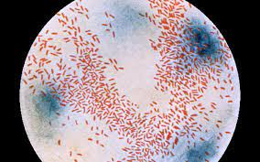
Important Properties
Hemophilus influenzae is a small gram-negative rod (coccobacillary rod)) with a polysaccharide capsule.It is one of the three important encapsulated pyogens, along with the pneumococcus and the meningococcus. Serologic typing is based on the antigenicity of the capsular polysaccharide. Of the six serotypes (a–f), type b is the most important. Type b used to cause most of the severe, invasive diseases, such as meningitis and sepsis, but the widespread use of the vaccine containing the type b capsular polysaccharide as the immunogen, has greatly reduced the incidence of invasive disease caused by this type. The type b capsule is composed of polyribitol phosphate. Unencapsulated strains can also cause disease, especially mucosal diseases of the upper respiratory tract such as sinusitis and otitis media, but are usually noninvasive. Growth of the organism on laboratory media requires the addition of two components, heme (factor X) and NAD (factor V), for adequate energy production.
Pathogenesis & Epidemiology
Hemophilus influenzae infects only humans; there is no animal reservoir. It enters the body by the inhalation of airborne droplets into the respiratory tract, resulting in either asymptomatic colonization or infections such as otitis media, sinusitis, or pneumonia. The organism produces an IgA protease that degrades secretory IgA, thus facilitating attachment to the respiratory mucosa. After becoming establishedin the upper respiratory tract, the organism can enter the bloodstream (bacteremia) and spread to the meninges. Meningitis is caused primarily by the encapsulated strains, but nonencapsulated strains are frequently involved in otitis media, sinusitis, and pneumonia. Note that the incidence of meningitis caused by capsular type b has been greatly reduced because the vaccine contains the type b polysaccharide as the immunogen. Pathogenesis of H. influenzae involves its antiphagocytic capsule and endotoxin; no exotoxin is produced. Most infections occur in children between the ages of 6 months and 6 years, with a peak in the age group from 6 months to 1 year. This age distribution is attributed to a decline in maternal IgG in the child coupled with the inability of the child to generate sufficient antibody against the polysaccharide capsular antigen until the age of approximately 2 years.
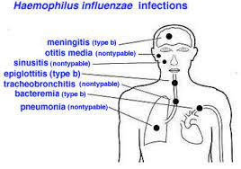
Clinical Findings
Meningitis caused by H. influenzae cannot be distinguished on clinical grounds from that caused by other bacterial pathogens (e.g., pneumococci or meningococci). The rapid onset of fever, headache, and stiff neck, along with drowsiness, is typical. Sinusitis and otitis media cause pain in the affected area, opacification of the infected sinus, and redness with bulging of the tympanic membrane. Hemophilus influenzae is second only to the pneumococcus as a cause of these two infections. Other serious infections caused by this organism include septic arthritis, cellulitis, and sepsis, the latter occurring especially in splenectomized patients. Rarely, epiglottitis, which can obstruct the airway, occurs. A swollen “cherryred” epiglottis is seen. This life-threatening disease of young children is caused almost exclusively by H. influenzae. Pneumonia in elderly adults, especially those with chronic respiratory disease, can be caused by untypeable strains of H. influenzae.
Laboratory Diagnosis
Laboratory diagnosis depends on isolation of the organism on heated-blood (“chocolate”) agar enriched with two growth factors required for bacterial respiration, namely, factor X (a heme compound) and factor V (NAD). The blood used in chocolate agar is heated to inactivate nonspecific inhibitors of H. influenzae growth. An organism that grows only in the presence of both growth factors is presumptively identified as H. influenzae; other species of Haemophilus, such as Haemophilus parainfluenzae, do not require both factors. Definitive identification can be made with either biochemical tests or the capsular swelling (quellung) reaction. Additional means of identifying encapsulated strains include fluorescent-antibody staining of the organism and counterimmunoelectrophoresis or latex agglutination tests, which detect the capsular polysaccharide.
Treatment
The treatment of choice for meningitis or other serious systemic infections caused by H. influenzae is ceftriaxone. From 20% to 30% of H. influenzae type b isolates produce a β-lactamase that degrades penicillinase-sensitive β-lactams such as ampicillin but not ceftriaxone. It is important to institute antibiotic treatment promptly, because the incidence of neurologic sequelae (e.g., subdural empyema) is high. Untreated H. influenzae meningitis has a fatality rate of approximately 90%. H. influenzae upper respiratory tract infections, such as otitis media and sinusitis, are treated with either amoxicillin-clavulanate or trimethoprim-sulfamethoxazole
Prevention
The vaccine contains the capsular polysaccharide of H. influenzae type b conjugated to diphtheria toxoid or other carrier protein. This vaccine is much more effective in young children than the unconjugated vaccine and has reduced the incidence of meningitis caused by this organism by approximately 90% in immunized children. Meningitis in close contacts of the patient can be prevented by rifampin. Rifampin is used because it is secreted in the saliva to a greater extent than ampicillin. Rifampin decreases respiratory carriage of the organism, thereby reducing transmission

GARDNERELLA
Gardnerella vaginalis is the main organism associated with bacterial vaginosis. This disease is the most common vaginal infection of sexually active women.
Important Properties
Gardnerella vaginalis is a small, facultative gram-variable rod. The term “gram-variable” refers to the observation that some organisms are purple while others are pink in a Gram-stained specimen. Structurally, it has a gram-positive cell wall but the wall is thin and older organisms tend to lose the purple color.
Pathogenesis
The pathogenesis of bacterial vaginosis is uncertain. Gardnerella vaginalis is often found in association with anaerobes such as Mobiluncus and together they cause the symptoms of this disease. It is not considered to be a sexually transmitted infection.
Clinical Findings
Bacterial vaginosis is characterized by a malodorous, white or gray-colored vaginal discharge. The discharge has a characteristic “fishy” odor. Inflammatory changes are typically absent which is why it is called a “vaginosis” rather than a “vaginitis.” Mild itching may occur. Women with bacterial vaginosis have a higher incidence of preterm deliveries and, consequently, a higher incidence of morbidity and mortality occurs in their newborn children.
Laboratory Diagnosis
Clue cells, which are vaginal epithelial cells covered with bacteria, are an important laboratory finding seen in a microscopic examination of the vaginal discharge (Figure 17-9). In addition, the “whiff” test, which consists of treating the vaginal discharge with 10% KOH and smelling a pungent, “fishy” odor, is often positive. However, trichomoniasis, which can also cause a positive whiff test, must be ruled out before a diagnosis of bacterial vaginosis can be made. A pH of greater than 4.5 of the vaginal discharge supports the diagnosis of bacterial vaginosis.
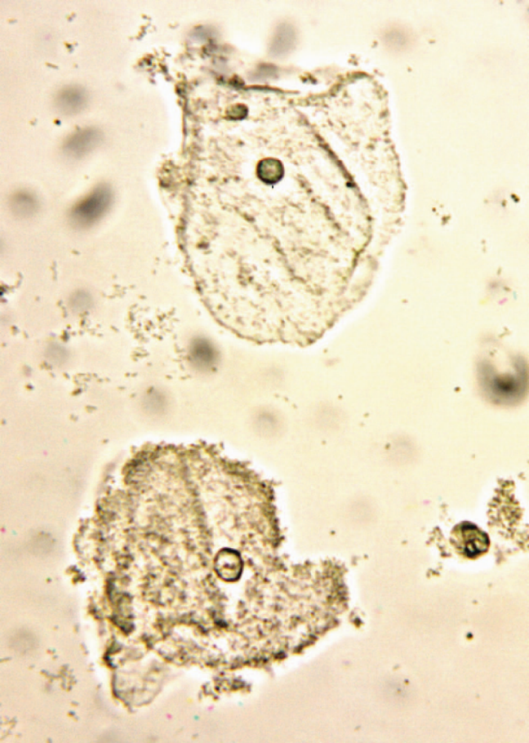
Clue cells in bacterial vaginosis. Note that the lower epithelial cell is a "clue cell" because its surface is covered with bacteria. The upper epithelial cell is not a "clue cell" because its surface has few bacteria.

Treatment and Prevention
The drug of choice is metronidazole. Treatment of sexual partners is not recommended. There is no vaccine.
LEGIONELLA
Disease
Legionella pneumophila (and other legionellae) causes pneumonia, both in the community and in hospitalized immunocompromised patients. The genus is named after the famous outbreak of pneumonia among people attending the American Legion convention in Philadelphia in 1976 (Legionnaires’ disease).
Important Properties
Legionellae are gram-negative rods that stain faintly with the standard Gram stain. They do, however, have a gram-negative type of cell wall, and increasing the time of the safranin counterstain enhances visibility. Legionellae in lung biopsy sections do not stain by the standard hematoxylin-and-eosin (H&E) procedure; therefore, special methods, such as the Dieterle silver impregnation stain, are used to visualize the organisms. During the 1976 outbreak, initial attempts to grow the organisms on ordinary culture media failed. This is because the organism requires a high concentration of iron and cysteine. Culture media supplemented with these nutrients will support growth. Legionella pneumophila causes approximately 90% of pneumonia attributed to legionellae. There are 16 serogroups of L. pneumophila, with most cases caused by serogroup 1 organisms. There are about 30 other Legionella species that cause pneumonia, but most of the remaining 10% of cases are caused by two species, Legionella micdadei and Legionella bozemanii.
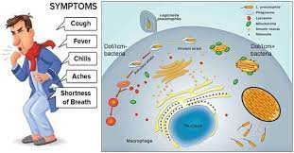
Pathogenesis & Epidemiology
Legionellae are associated chiefly with environmental water sources such as air conditioners and water-cooling towers. Outbreaks of pneumonia in hospitals have been attributed to the presence of the organism in water taps, sinks, and showers. Legionellae can replicate to large numbers in free-living amebas in these water sources. The amebas also enhance the survival of Legionellae. Under adverse environmental conditions, the amebas encyst, ensuring both their own survival and the survival of the intracellular Legionellae as well. The portal of entry is the respiratory tract, and pathologic changes occur primarily in the lung. However, in severe cases, bacteremia occurs, accompanied by damage to the vascular endothelium in multiple organs, especially the brain and kidneys. The major virulence factor of the organism is lipopolysaccharide (endotoxin). No exotoxins are produced. The typical candidate for Legionnaires’ disease is an older man who smokes and consumes substantial amounts of alcohol. Patients with acquired immunodeficiency syndrome (AIDS), cancer, or transplants (especially renal transplants) or patients being treated with corticosteroids are predisposed to Legionella pneumonia, which indicates that cell-mediated immunity is the most important defense mechanism. Despite airborne transmission of the organism, person-toperson spread does not occur, as shown by the failure of secondary cases to occur in close contacts of patients.
Clinical Findings
The clinical picture can vary from a mild influenzalike illness to a severe pneumonia accompanied by mental confusion, nonbloody diarrhea, proteinuria, and microscopic hematuria. Although cough is a prominent symptom, sputum is frequently scanty and nonpurulent. Hyponatremia is an important laboratory finding that occurs more often in Legionella pneumonia than in pneumonia caused by other bacteria. Most cases resolve spontaneously in 7 to 10 days, but in older or immunocompromised patients, the infection can be fatal. Legionellosis is an atypical pneumonia2 and must be distinguished from other similar pneumonias such as Mycoplasma pneumonia, viral pneumonia, psittacosis, and Q fever. Pontiac fever is a mild, flulike form of Legionella infection that does not result in pneumonia.
Laboratory Diagnosis
Sputum Gram stains reveal many neutrophils but no bacteria. The organism fails to grow on ordinary media in a culture of sputum or blood, but it will grow on charcoalyeast agar, a special medium supplemented with iron and cysteine. Diagnosis usually depends on a significant increase in antibody titer in convalescent-phase serum by the indirect immunofluorescence assay. Detection of L. pneumophila antigens in the urine is a rapid means of making a diagnosis. The urinary antigen test is available only for serogroup 1 organisms. If tissue is available, it is possible to demonstrate Legionella antigens in infected lung tissue by using fluorescent-antibody staining. The cold-agglutinin titer does not rise in Legionella pneumonia, in contrast to pneumonia caused by Mycoplasma.
Treatment
Azithromycin or erythromycin (with or without rifampin) is the treatment of choice. Certain fluoroquinolones, such as levofloxacin and trovafloxacin, are also drugs of choice. These drugs are effective not only against L. pneumophila, but also against Mycoplasma pneumoniae and Streptococcus pneumoniae. The organism frequently produces β-lactamase, and so penicillins and cephalosporins are less effective.
Prevention
Prevention involves reducing cigarette and alcohol consumption, eliminating aerosols from water sources, and reducing the incidence of Legionella in hospital water supplies by using high temperatures and hyperchlorination.There is no vaccine.

